|  |
| --- |
|  |
| **Homebush State School** |

2024-2027

**Student**

**Code of Conduct**

**Equity and Excellence**

A progressive, high performing education system realising the potential of every student.

|  |
| --- |
| Contact Information |
|  |

|  |  |
| --- | --- |
| Postal address: 1181 Homebush Rd Mackay QLD 4740 |  |
| Phone: 07 49597286 |  |
| Email: admin@homebushss.eq.edu.au | |  |
| School website address: <https://homebushss.eq.edu.au/> | |  |
| Contact Person: Sue Redman | |  |

|  |
| --- |
| Endorsement (Mandated) |
|  |

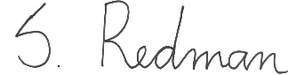

Sue Redman

Principal Homebush SS

|  |
| --- |
| Contents |
|  |

Purpose 4

Consultation 4

Data Overview 5-8

Review Statement

School Disciplinary Absences

School Opinion Survey

Behaviour Incidence Reports

Learning and Behaviour Statement 9-12

Multi-Tiered Systems of Support

Consideration of Individual Circumstances

Student Wellbeing

Student Support Network

Whole School Approach to Discipline 13-16

Differentiated and Explicit Teaching

Focussed Teaching

Intensive Teaching

Legislative Delegations 16-17

Legislation

Delegations

Disciplinary Consequences 18-25

School Policies 25-34

Temporary removal of student property

Use of mobile phones and other devices by students

Preventing and responding to bullying

Appropriate use of social media

Restrictive Practices 35

Critical Incidents 36

Resources 37

Conclusion 38-39

|  |
| --- |
| Purpose |
|  |

Homebush State School is committed to providing a safe, respectful and disciplined learning environment for students and staff, where students have opportunities to engage in quality learning experiences and acquire values supportive of their lifelong wellbeing.

The Homebush State School Student Code of Conduct sets out the responsibilities and processes we use in our school to promote a productive, effective whole school approach to discipline.

Its purpose is to facilitate high standards of behaviour from all in the school community, ensuring learning and teaching in our school can be effective and students can participate positively and productively.

|  |
| --- |
| Consultation |
|  |

The consultation process used to inform the development of the Homebush SS Student Code of Conduct occurred in three phases.

In the first phase, we held a meeting with teaching staff in February 2020. During this meeting, we examined a range of data sets on student attendance, school disciplinary absences and outcomes from the most recent School Opinion Survey. We identified strengths and successes from our previous school behaviour plan, and areas for further development.

In the second phase, a draft Student Code of Conduct was prepared and distributed for comment to all members of the school community. Modifications were made to the plan in response to feedback.

Finally, the third phase of consultation was completed in _, and the finished version, incorporating suggested changes and feedback, was sent to the P&C Association meeting in March 2020 for endorsement.

**Review Statement**

The Homebush SS Student Code of Conduct will undergo annual minor updates to reflect changing circumstances, data and staff. A fulsome review will be conducted every four years in line with the scheduled review process for the School Planning, Reviewing and Reporting cycle.

|  |
| --- |
| Data Overview |
|  |

OneSchool is the central repository for recording behaviour incidents and attendance. Data from OneSchool is used to inform our Student Code of Conduct. Personal and disciplinary absences, School Opinion Survey Data and behaviour incidents for the previous 3 years (2017-2019) were all considered in the creation of this policy. Parents who wish to access their child’s One School record need to submit a written request to the principal.

**School Disciplinary Absences**

Principals use a range of disciplinary consequences to address inappropriate behaviour. Suspensions, exclusions and cancellations of enrolment are only used as a last resort option for addressing serious behaviour issues. Principals balance individual circumstances and the actions of the student with the needs and rights of school community members.

All state schools are required to report School Disciplinary Absences (SDA) for the school year in their school annual report. There are four main categories of SDA: short suspension, long suspension, exclusion and charge-related suspension.

The following graphs shows the count of incidents for students recommended for each type of school disciplinary absence reported at the school as well as absences for personal reasons.

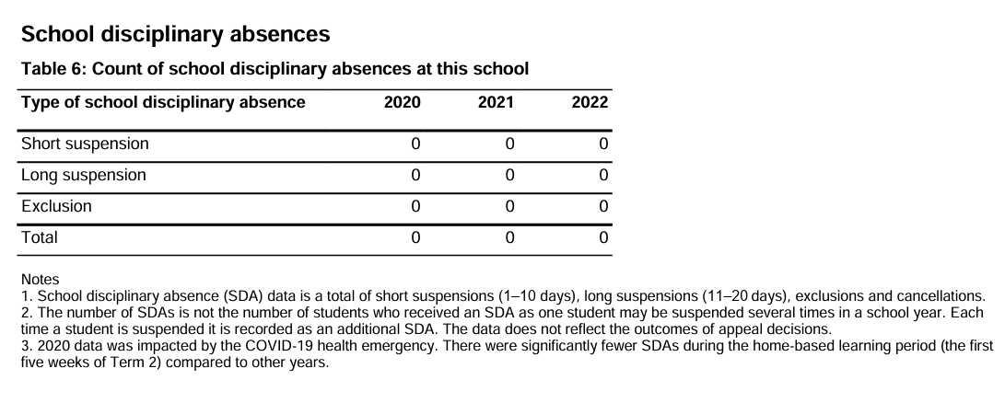

**School Opinion Survey**

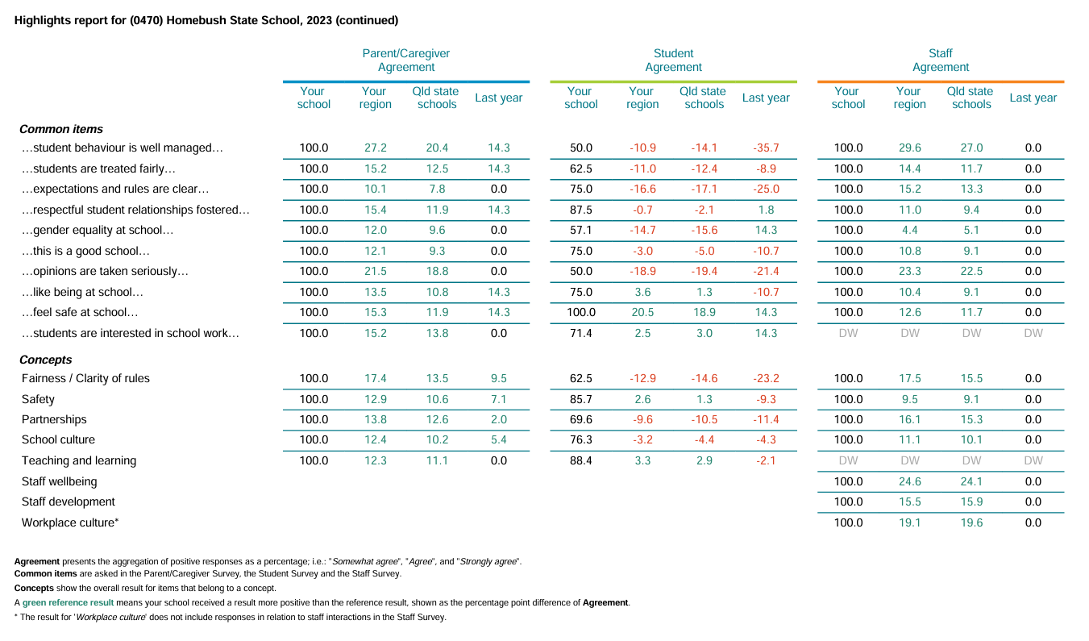The Parent and Student Satisfaction data in the tables below is drawn from the School Opinion Survey 2023. The School Opinion Survey is an annual collection designed to obtain the views of parents/caregivers, students and school staff from each school on what they do well and how they can improve. Opinions on the school, student learning, and student wellbeing are sought from a parent/caregiver in all families and a sample of students from each state school.

**Behaviour Incident Reports**

Behaviour incidents that result in a white or yellow card being issued or are considered significant for a variety of reasons, are recorded on One School. This allows patterns and trends in behaviour to be tracked and examined. Part of the process of creating the Homebush SS Student Code of Conduct was to table these reports at staff meetings for general discussion.

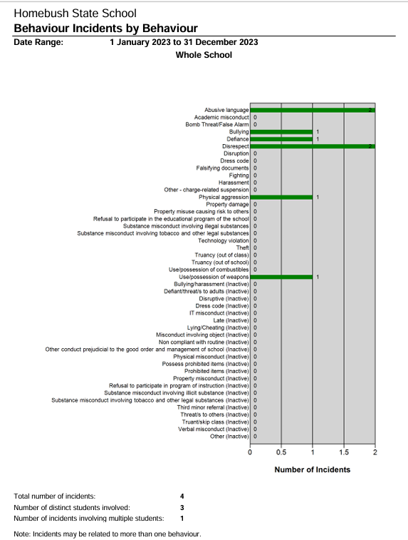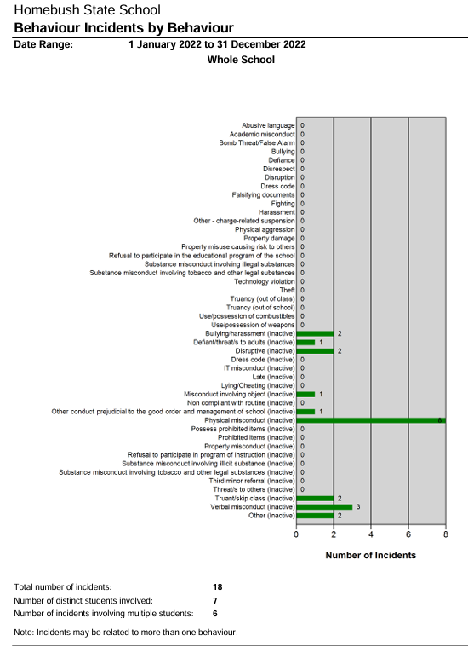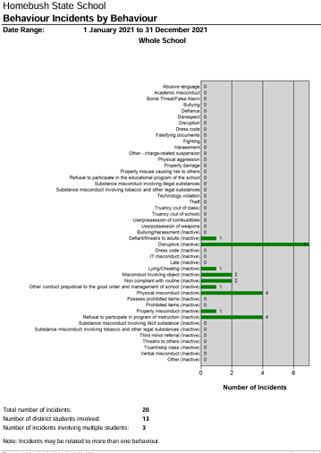

|  |
| --- |
| Learning and Behaviour Statement |
|  |

Everyone brings their own sets of personal beliefs to a school community. These beliefs influence their decisions, behaviour and social practices. It is reasonable to expect that not everyone will share the same sets of beliefs, and this contributes to a richly diverse social environment in each school. It can also contribute to differences in expectations and force us to reflect on our own understanding of what we consider acceptable and unacceptable. We encourage any student or parent to make an appointment with the principal to discuss the model of behaviour support and discipline used at this school.

**Multi-Tiered Systems of Support**

Homebush SS uses multi-tiered systems of support as the foundation for our integrated approach to learning and behaviour. This is a preventative, differentiated model grounded in practical strategies, targeted planning and data-informed decision-making. Based on a problem-solving model, school staff match increasingly intensive interventions to the identified needs of individual students.

|  |  |
| --- | --- |
| **Tier** | **Prevention Description** |
| **1** | **All students** in the school receive support for their academic and behavioural development. Focus is on the whole-school implementation of the Australian Curriculum. This involves:   * teaching behaviours in the setting they will be used * being consistent when addressing challenging behaviour, while taking developmental norms and behavioural function into account * providing refresher lessons and targeted recognition throughout the school year so skills are ready and likely to be used when students need them * asking students and their families for their perspectives on school climate, instruction, reinforcement, and discipline so improvements in Tier 1 may be made. |
| **2** | Targeted instruction and supports for **some students** are more intense that Tier 1 services to enable students to meet the required academic and behavioural standards. Tier 2 supports build on the lessons provided at Tier 1, and may prevent the need for more intensive interventions. Tier 2 supports are provided to individual or small groups of students with similar needs, offering more time and/or detailed instruction on the Australian Curriculum. The types of interventions offered at this level will vary according to the needs of our student body, but all have certain things in common:   * there is a clear connection between the skills taught in the interventions and the school-wide expectations. * interventions require little time of classroom teachers and are easy to sustain * interventions have a good chance of working (e.g., they are matched to the student’s need).   If the school data indicates that more than 10-15% of students require targeted services, then a review of Tier 1 is needed to address the basic implementation and quality of instruction. |
| **3** | Individualised services for a **few students** who require the most intensive support a school can provide. These are usually delivered on an individual basis.  Tier 3 supports continue to build on the lessons and supports provided at Tiers 1 and 2, becoming more individualised and more intensive until teams can identify what is needed for a student to be successful. Tier 3 supports are based on the underlying reasons for a student’s behaviour and should include strategies to:   * PREVENT problem behaviour * TEACH the student an acceptable replacement behaviour * REINFORCE the student’s use of the replacement behaviour * MINIMISE the payoff for problem behaviour.   If the school data indicates that more than 2-5% of the student population requires individualised services, a review of Tier 1 and Tier 2 supports and organisation is recommended. |

**Consideration of Individual Circumstances**

Staff at Homebush SS take into account students’ individual circumstances, such as their behaviour history, disability, mental health and wellbeing, religious and cultural considerations, home environment and care arrangements when teaching expectations, responding to inappropriate behaviour or applying a disciplinary consequence.

In considering the individual circumstances of each student, we recognise that the way we teach, the support we provide and the way we respond to students will differ. This reflects the principle of equality, where every student is given the support they need to be successful. This also means that not everyone will be treated the same, because treating everyone the same is not fair. For example, some students need additional support to interpret or understand an expectation. Others may benefit from more opportunities to understand an expectation. Others may benefit from more opportunities to practise a required skill or behaviour. For a small number of students, the use of certain disciplinary consequences may be considered inappropriate or ineffective due to complex trauma or family circumstances. These are all matters that our teachers and principal consider with each individual student in both the instruction of behaviour and the response to behaviour.

Our teachers are also obliged by law to respect and protect the privacy of individual students, so while we understand the interest of other students, staff and parents to know what punishment another student might have received, we will not disclose or discuss this information with anyone but the student’s family. This applies even if the behavioural incident, such as bullying, involves your child. You can be assured that school staff take all matters, such as bullying, very seriously and will address them appropriately. We expect that parents and students will respect the privacy of other students and families.

If you have concerns about the behaviour of another student at the school, or the way our staff have responded to their behaviour, please make an appointment with the principal to discuss the matter.

**Student Wellbeing**

Learning and wellbeing are inextricably linked — students learn best when their wellbeing is optimised, and they develop a strong sense of wellbeing when they experience success in learning. The student learning and wellbeing framework supports state schools with creating positive school cultures and embedding student wellbeing in all aspects of school life through connecting the learning environment, curriculum and pedagogy, policies, procedures and partnerships for learning and life.

**Curriculum and pedagogy**

Schools build the foundations for wellbeing and lifelong learning through curriculum embedding personal and social capabilities (self-awareness, self-management, social awareness and social management) in the implementation of the P–12 curriculum, assessment and reporting framework.

Schools acknowledge the positive impact that a meaningful relationship between teacher and students can have on students' academic and social outcomes. As part of the whole school's curriculum at Homebush SS, we provide age-appropriate drug and alcohol education through the Life Education Program and Health and Physical Education Curriculum.

**Policy and expectations**

Within a school community there are specific health and wellbeing issues that will need to be addressed for the whole school, specific students, or in certain circumstances.

*Specialised health needs*

Homebush SS works closely with parents to ensure students with specialised health needs, including those requiring specialised health procedures, have access to a reasonable standard of support for their health needs whilst attending school or school-based activities.

This means that appropriate health plans are developed and followed for students with specialised health needs, that staff are aware of the student's medical condition and that an appropriate number of staff have been trained to support the student's health condition.

*Medications*

Homebush SS requires parent consent and medical authorisation to administer any medication (including over-the-counter medications) to students. For students requiring medication to be administered during school hours, the school can provide further information and relevant forms.

For students with a long-term health condition requiring medication, parents need to provide the school with a [*Request to administer medication at school*](http://ppr.det.qld.gov.au/education/management/Pages/Administration-of-Medications-in-Schools.aspx) form signed by the prescribing health practitioner.

Homebush SS maintains one adrenaline auto-injector and asthma reliever/puffer, stored in the school's first aid kit to provide emergency first aid medication if required.

**Student Support Network**

Students can approach any trusted school staff member at Homebush SS to seek assistance or advice. If they are unable to assist they will provide guidance and help ensure the student is connected to the appropriate person.

It is also important for students and parents to understand there are regional and state-wide support services also available to supplement the school network. These include Principal Advisor Student Protection, Mental Health Coach, Autism Coach, Inclusion Coach, Success Coach, Advisory Visiting Teachers and Senior Guidance Officers. For more information about these services and their roles, please speak with the principal.

|  |
| --- |
| Whole School Approach to Discipline |
|  |

At Homebush SS we believe discipline is about more than punishment. Student behaviour is a part of the overall teaching and learning approach in our school. Our staff take responsibility for making their expectations clear, for providing supportive instruction about how to meet these expectations and strive to use behavioural incidents as opportunities to re-teach.

Our staff understand that the Australian Professional Standards for Teachers (standard 4) describes how teachers can “Create and maintain supportive and safe learning environments” to underpin our whole school approach to discipline;

4.1 Support student participation

Identify strategies to support inclusive student participation and engagement in classroom activities.

4.2 Manage classroom activities

Demonstrate the capacity to organise classroom activities and provide clear directions

4.3 Manage challenging behaviour

Demonstrate knowledge of practical approaches to manage challenging behaviour

4.4 Maintain student safety

Describe strategies that support students’ wellbeing and safety working within school and/or system, curriculum and legislative requirements

4.5 Use ICT safely, responsibly and ethically

Demonstrate an understanding of the relevant issues and the strategies available to support the safe, responsible and ethical use of ICT in learning and teaching

At times a student’s individual circumstances, such as the student’s behaviour history, disability, mental health and wellbeing, religious and cultural considerations, home environment and care arrangements are taken into account when responding to inappropriate behaviour and applying a disciplinary consequence. One School records are used, such as [Personalised Learning and Support Provisions](https://oneschoolhelp.eq.edu.au/Student%20Support/StudentPlan/Pages/default.aspx), to document supports.

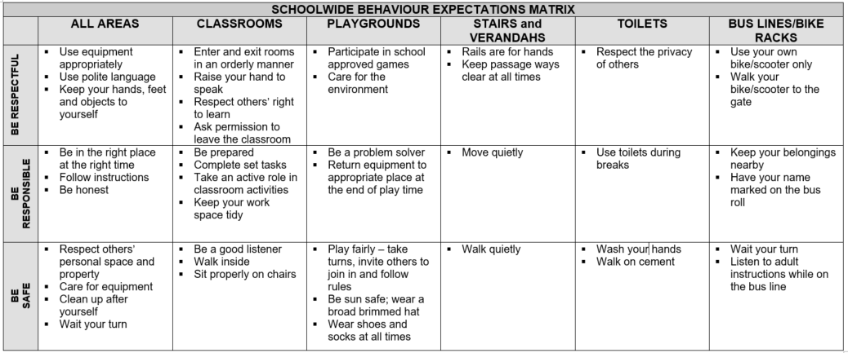At Homebush State School we emphasise the importance of directly teaching students the behaviours we want them to demonstrate at school. Communicating behavioural expectations is a form of universal behaviour support - a strategy designed to prevent problem behaviour and to provide a framework for responding to unacceptable behaviour. A set of behavioural expectations in specific settings has been attached to each of our three school rules. The Schoolwide Behaviour Expectations Matrix (below) outlines our agreed rules and specific behavioural expectations in all school settings.

**Reinforcing expected school behaviour**

At Homebush State School our key messages about behaviour are reinforced with the goal of increasing the quantity and quality of positive interactions between students and staff. Students are provided with regular feedback about their behaviour designed to give them opportunities to meet expectations. Communication books are used in all classrooms to share not only routines and updates but also the positive behaviour of students with their parents.

Individual classrooms have negotiated systems of rewards for positive behaviour. In the infant’s classroom these are concrete as befits the students’ stage of development. Positive behaviour is rewarded with stickers which are displayed on individual charts, students completing their charts select from a prize box. The online Class Dojo platform is used to reward positive behaviours via an app. Parents are able to join the virtual space and monitor student progress. The reports that this app generates provide an evidential base for parent-teacher conversations about student behaviour.

‘Student of the Week’ for each classroom is awarded on Friday parade in front of all staff, students and visiting parents. It recognizes the effort of students who have excelled in any particular area that week. Photographs of students awarded this honour are published in the school newsletter. End of term reward days are much anticipated by the vast majority of Homebush State School students whose behaviour is consistently positive.

.

**Consideration of Individual Circumstances**

The individual circumstances of students are considered by staff when providing support and determining appropriate consequences for disciplinary matters.

Confidentiality obligations limit discussion or sharing information about individual circumstances of students, including applied disciplinary consequences, with persons other than the student’s parent/s.

**Differentiated and Explicit Teaching**

Homebush SS is a disciplined school environment that provides differentiated teaching to respond to the learning needs of all students. This involves teaching expected behaviours and providing opportunities for students to practise these behaviours. Teachers reinforce expected behaviours, provide feedback and correction, and opportunities for practise.

Teachers at Homebush SS vary what students are taught, how they are taught and how students can demonstrate what they know as part of this differentiated approach to behaviour. These decisions about differentiation are made in response to data and day-to-day monitoring that indicates the behavioural learning needs of students. This enables our teachers to purposefully plan a variety of ways to engage students; assist them to achieve the expected learning; and to demonstrate their learning.

There are three main layers to differentiation, as illustrated in the diagram below. This model is the same used for academic and pedagogical differentiation.

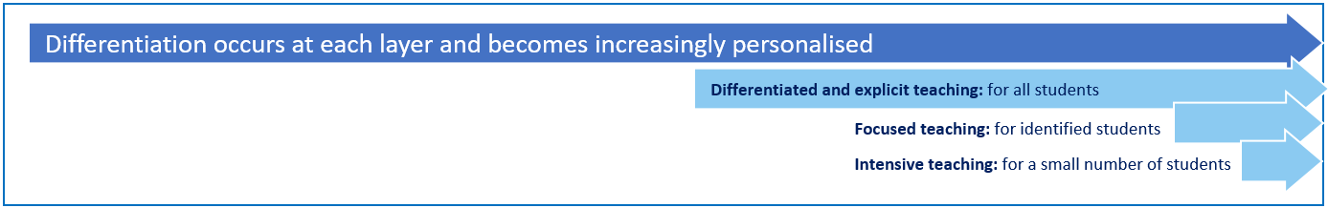

These three layers map directly to the tiered approach discussed earlier in the Learning and Behaviour section. Each layer provides progressively more personalised supports for students.

**Focused Teaching**

Approximately 15% of all students in any school or classroom may require additional support to meet behaviour expectations, even after being provided with differentiated and explicit teaching. These students may have difficulty meeting behavioural expectations in a particular period of the day or as part of a learning area/subject, and focused teaching is provided to help them achieve success.

Focused teaching involves revisiting key behavioural concepts and/or skills and using explicit and structured teaching strategies in particular aspects of a behaviour skill. Focused teaching provides students with more opportunities to practise skills and multiple opportunities to achieve the intended learning and expected behaviour. Student progress is monitored by the classroom teacher/s to identify those who:

* no longer require the additional support
* require ongoing focussed teaching
* require intensive teaching.

**Intensive Teaching**

Research evidence shows that even in an effective, well-functioning school there will always be approximately 5% of the student population who require intensive teaching to achieve behavioural expectations. Intensive teaching involves frequent and explicit instruction, with individuals or in small groups, to develop mastery of basic behavioural concepts, skills and knowledge.

Some students may require intensive teaching for a short period, for particular behaviour skills. Other students may require intensive teaching for a more prolonged period. Decisions about the approach will be made based on data collected from their teacher or teachers, and following consultation with the student’s family.

For a small number of students who continue to display behaviours that are deemed complex and challenging, then individualised, function-based behaviour assessment and support plans and multi-agency collaboration may be provided to support the student. This approach will seek to address the acute impact of barriers to learning and participation faced by students who are negotiating a number of complex personal issues.

|  |
| --- |
| Legislative Delegations |
|  |

**Legislation**

In this section of the Student Code of Conduct, we have provided links to relevant legislation that inform the overall Student discipline procedure.

* [Anti-Discrimination Act 1991 (Qld)](http://www8.austlii.edu.au/cgi-bin/viewdb/au/legis/qld/consol_act/aa1991204/)
* [Child Protection Act 1999 (Qld)](https://www.legislation.qld.gov.au/view/html/inforce/current/act-1999-010)
* [Commonwealth Disability Discrimination Act 1992](https://www.legislation.gov.au/Details/C2016C00763)
* [Commonwealth Disability Standards for Education 2005](https://docs.education.gov.au/node/16354)
* [Criminal Code Act 1899 (Qld)](https://www.legislation.qld.gov.au/view/html/inforce/2018-03-16/act-1899-009)
* [Education (General Provisions) Act 2006](https://www.legislation.qld.gov.au/view/html/inforce/2018-05-01/act-2006-039)
* [Education (General Provisions) Regulation 2017](http://classic.austlii.edu.au/au/legis/qld/consol_reg/epr2017396/)
* [Human Rights Act 2019 (Qld)](https://www.legislation.qld.gov.au/view/html/asmade/act-2019-005)
* [Information Privacy Act 2009 (Qld)](https://www.legislation.qld.gov.au/view/html/inforce/current/act-2009-014)
* [Judicial Review Act 1991 (Qld)](https://www.legislation.qld.gov.au/view/html/inforce/current/act-1991-100)
* [Right to Information Act 2009 (Qld)](https://www.legislation.qld.gov.au/view/html/inforce/current/act-2009-013)
* [Police Powers and Responsibilities Act 2000 (Qld)](http://www8.austlii.edu.au/cgi-bin/viewdb/au/legis/qld/consol_act/ppara2000365/)
* [Workplace Health and Safety Act 2011 (Qld)](https://www.legislation.qld.gov.au/view/html/inforce/2018-07-01/act-2011-018)
* [Workplace Health and Safety Regulation 2011 (Cwth)](https://www.legislation.gov.au/Details/F2011L02664)

**Delegations**

Under the Education (General Provisions) Act 2006, state school principals are responsible for “controlling and regulating student discipline in the school”.

Principals are afforded a number of **non-delegable powers** to assist them to meet this obligation, including the authority to suspend, exclude or cancel the enrolment of a student at the school. These decision-making responsibilities cannot be delegated to other staff in the school, such as deputy principals.

The details of these responsibilities are outlined in the legislative instruments of delegation and instruments of authorisation provided below:

* [Education (General Provisions) Act 2006 Director-General’s delegations](http://ppr.det.qld.gov.au/pif/authorities/Authorities%20and%20Delegations/Director-Generals%20delegations%20under%20Education%20(General%20Provisions)%20Act%202006.pdf)
* [Education (General Provisions) Act 2006 Minister’s delegations](http://ppr.det.qld.gov.au/pif/authorities/Authorities%20and%20Delegations/Ministers%20delegations%20under%20Education%20(General%20Provisions)%20Act%202006.pdf)
* [Education (General Provisions) Act 2006 Director-General’s authorisations](http://ppr.det.qld.gov.au/pif/authorities/Authorities%20and%20Delegations/Director-Generals%20authorisations%20under%20Education%20(General%20Provisions)%20Act%202006.pdf)
* [Education (General Provisions) Regulation 2006 Minister’s delegations](http://ppr.det.qld.gov.au/pif/authorities/Authorities%20and%20Delegations/Ministers%20delegations%20under%20Education%20(General%20Provisions)%20Regulation%202006.pdf)
* [Education (General Provisions) Regulation 2017 Director-General’s delegations](http://ppr.det.qld.gov.au/pif/authorities/Authorities%20and%20Delegations/Director-Generals%20delegations%20under%20Education%20(General%20Provisions)%20Regulation%202017.pdf)

|  |
| --- |
| Disciplinary Consequences |
|  |

The disciplinary consequences model used at Homebush SS follow the same differentiated approach used in the proactive teaching and support of student behavioural expectations.

The majority of students will be confident and capable of meeting established expectations that are clear, explicitly taught and practised. In-class corrective feedback, sanctions and rule reminders may be used by teachers to respond to low-level or minor problem behaviours.

Some students will need additional support, time and opportunities to practise expected behaviours. Approximately 15% of the student population may experience difficulty with meeting the stated expectations, and even with focussed teaching, in-class corrective feedback, sanctions and rule reminders continue to display low-level problem behaviour. A continued pattern of low-level behaviour can interfere with teaching and learning for the whole class, and a decision may be needed by the class teacher to refer the student to the school administration team immediately for determination of a disciplinary consequence.

For a small number of students, approximately 2-5%, a high level of differentiated support or intensive teaching is required to enable them to meet the behavioural expectations. This may be needed throughout the school year on a continuous basis. The determination of the need will be made by the principal in consultation with staff and other relevant stakeholders. On occasion the behaviour of a student may be so serious, such as causing harm to other students or to staff, that the principal may determine that an out of school suspension or exclusion is necessary as a consequence for the student’s behaviour. Usually this course of action is only taken when the behaviour is either so serious as to warrant immediate removal of the student for the safety of others, and no other alternative discipline strategy is considered sufficient to deal with the problem behaviour.

The differentiated responses to problem behaviour can be organised into three tiers, with increasing intensity of support and consequences to address behaviour that endangers others or causes major, ongoing interference with class or school operations.

**Differentiated**

Class teachers provide in-class or in-school disciplinary responses to low-level or minor problem behaviour. This may include:

* Pre-correction (e.g. “Remember, walk quietly to your seat”)
* Non-verbal and visual cues (e.g. posters, hand gestures)
* Whole class practising of routines
* Corrective feedback (e.g. “Hand up when you have a question”)
* Rule reminders (e.g. “We walk on concrete”)
* Explicit behavioural instructions (e.g. “Pick up your pencil”)
* Proximity control
* Tactical ignoring of inappropriate behaviour
* Revised seating plan and relocation of student/s
* Individual positive reinforcement for appropriate behaviour
* Reminders of incentives or class goals
* Redirection
* Break down tasks into smaller chunks
* Provide positive choice of task order (e.g. “Which one do you want to start with?”)
* Prompt student to take a break or time out (e.g. thinking step)
* Model appropriate language, problem solving and verbalise thinking process (e.g. “I’m not sure what is the next step, who can help me?”)
* Provide demonstration of expected behaviour
* Peer consequence (e.g. corrective feedback to influential peer demonstrating same problem behaviour)
* Private discussion with student about expected behaviour
* Reprimand for inappropriate behaviour
* Logical consequences (e.g. clean up mess or complete unfinished work)
* Stakeholder meeting with parents
* White behaviour warning card issued

A white behaviour warning card may be issued to communicate low level or minor problem behaviours to parents. This is usually only after a range of in-class behaviour modification strategies have been employed. Parents will also be notified via a phone call.

There is no behaviour that will lead to the automatic issuing of a white card. The child’s individual circumstances will always be taken into account. A stake holder meeting with parents or phone call will follow up the issuing of a white card.

All white cards are recorded on One School to allow behaviour incident data to be collated and acted upon. Students and parents are provided with a summary of typical white card behaviours in communication books at the beginning of each year:

|  |  |  |
| --- | --- | --- |
|  | **Area** | **White Card Behaviour** |
| **Being Safe** | Movement around school | * Running on concrete or around or in buildings * Riding a bike in school grounds |
| Play | * Incorrect use of equipment * Not playing safe games * Playing in toilets |
| Physical contact | * Minor physical contact (pushing and shoving) |
| **Being Responsible** | Class tasks | * Not completing set tasks that are at an appropriate level * Refusing to work |
| Being in the right place | * Not in the right place at the right time. |
| Follow instructions | * Low intensity failure to respond to adult request * Unco-operative behaviour |
| Be honest | * Minor dishonesty |
| Rubbish | * Littering |
| ICTs | * Mobile phone switched on without authorisation * Photograph or video another person without permission |
| **Being Respectful** | Language | * Inappropriate language (written/verbal) * Poor attitude * Disrespectful tone |
| Property | * Petty theft * Lack of care for the environment |
| Others | * Not playing fairly * Minor disruption to class * Minor defiance * Minor bullying / harassment |

**Focussed**

The Class teacher is supported by other school-based staff to address in-class problem behaviour. This may include:

* Individual student behaviour support strategies (e.g. Student behaviour plan)
* Targeted skills teaching in small group
* Detention
* Behavioural contract
* Counselling and guidance support
* Stakeholder meeting with parents
* Yellow behaviour card issued

A yellow behaviour card may be issued to communicate major problem behaviours to parents. There is no behaviour that will lead to the automatic issuing of a yellow card. The child’s individual circumstances will always be taken into account. A stake holder meeting with parents or phone call will follow up the issuing of a yellow card. Children with two or more yellow cards are excluded from end of term Behaviour Rewards Day.

All yellow cards are recorded on One School to allow behaviour incident data to be collated and acted upon. Students and parents are provided with a summary of typical yellow card behaviours in communication books at the beginning of each year:

|  |  |  |
| --- | --- | --- |
|  | **Area** | **Major: Yellow Card Behaviour** |
| **Being Safe** | Play | * Throwing objects with intent to harm another person |
| Physical contact | * Fighting |
| **Being Responsible** | Being in the right place | * Leaving school grounds without permission |
| Be honest | * Major dishonesty |
| ICT | * Use of a mobile phone without authorisation * Use of a computer or iPad without authorisation |
| **Being**  **Respectful** | Language | * Offensive language * Aggressive language |
| Property | * Vandalism |
| Others | * Major disruption to class * Major defiance |

**INTENSIVE**

The School leadership team work in consultation with the teacher to address persistent or ongoing serious problem behaviour. This may include:

* Functional Behaviour Assessment based individual support plan
* Complex case management and review
* Stakeholder meeting with parents and external agencies
* Temporary removal of student property (e.g. mobile phone)
* Short term suspension (up to 10 school days)
* Long term suspension (up to 20 school days)
* Charge related suspension (student has been charged with a serious criminal offence is suspended from school until the charge has been dealt with by the relevant justice authorities)
* Suspension pending exclusion (student is suspended from school pending a decision by the Director-General or delegate (principal) about their exclusion from school)
* Exclusion (student is excluded from a particular state school site, a group of state schools or all state schools in Queensland for a defined period of time or permanently)
* Red behaviour card issued

A red behaviour card may be issued to communicate major problem behaviours to parents. There is no behaviour that will lead to the automatic issuing of a red card. The child’s individual circumstances will always be taken into account. A stake holder meeting with parents or phone call will follow up the issuing of a red card. Children with a red card are excluded from excursions and the end of term Behaviour Rewards Day.

All red cards are recorded on One School to allow behaviour incident data to be collated and acted upon. Students and parents are provided with a summary of typical red card behaviours in communication books at the beginning of each year:

|  |  |  |
| --- | --- | --- |
|  | **Area** | **Serious: Red Card Behaviour** |
| **Being Safe** | Play | * Possession and/or use of weapons |
| Physical contact | * Serious physical aggression |
| Other | * Possession and/or selling of drugs |
| **Being Responsible** | ICTs | * Cyber bullying * Download and/or distribute inappropriate materials |
| **Being**  **Respectful** | Language | * Verbal threats and/or abuse |
| Property | * Stealing/major theft * Wilful property damage |
| Others | * Major bullying/harassment |

**School Disciplinary Absences**

A School Disciplinary Absence (SDA) is an enforced period of absence from attending a Queensland state school, applied by the Principal as a consequence to address poor student behaviour. There are four types of SDA:

* Short suspension (1 to 10 school days)
* Long suspension (11 to 20 school days)
* Charge-related suspension
* Exclusion (period of not more than one year or permanently).

At Homebush SS, the use of any SDA is considered a very serious decision. It is typically only used by the Principal when other options have been exhausted or the student’s behaviour is so dangerous that continued attendance at the school is considered a risk to the safety or wellbeing of the school community.

Parents and students may appeal a long suspension, charge-related suspension or exclusion decision. A review will be conducted by the Director-General or their delegate, and a decision made within 40 schools days to confirm, amend/vary or set aside the original SDA decision by the Principal.

The appeal process is a thorough review of all documentation associated with the SDA decision and provides an opportunity for both the school and the family to present their case in the matter. Time is afforded for collection, dissemination and response to the materials by both the school and the family. It is important that the purpose of the appeal is understood so that expectations are clear, and appropriate supports are in place to ensure students can continue to access their education while completing their SDA.

**Re-entry following suspension**

Students who are suspended from Homebush SS may be invited to attend a re-entry meeting on the day of their scheduled return to school. The main purpose of this meeting is to welcome the student, with their parent/s, back to the school. It is **not a time** to review the student’s behaviour or the decision to suspend, the student has already received a punishment through their disciplinary absence from school. The aim of the re-entry meeting is for school staff to set the student up for future success and strengthen home-school communication.

It is not mandatory for the student or their parents to attend a re-entry meeting. It may be offered as a support for the student to assist in their successful re-engagement in school following suspension.

**Arrangements**

The invitation to attend the re-entry meeting will be communicated via telephone and in writing, usually via email. Re-entry meetings are short, taking less than 10 minutes, and kept small with only the Principal or their delegate attending with the student and their parent/s.

A record of the meeting is saved in OneSchool, under the Contact tab, including any notes or discussions occurring during the meeting.

**Structure**

The structure of the re-meeting should follow a set agenda, shared in advance with the student and their family. If additional items are raised for discussion, a separate arrangement should be made to meet with the parent/s at a later date and time. This meeting should be narrowly focussed on making the student and their family feel welcome back into the school community.

Possible agenda:

* Welcome back to school
* Check in on student wellbeing
* Discuss any recent changes to school routine or staffing
* Offer information about supports available (e.g. guidance officer)
* Set a date for follow-up
* Thank student and parent/s for attending
* Walk with student to classroom

**Reasonable adjustments**

In planning the re-entry meeting, school staff will consider reasonable adjustments needed to support the attendance and engagement of the student. This includes selecting an appropriate and accessible meeting space, organising translation or interpretation services or supports (e.g. AUSLAN), provision of written and/or pictorial information and other relevant accommodations. The inclusion of support staff, such as guidance officers or Community Education Counsellors, may also offer important advice to ensure a successful outcome to the re-entry meeting.

|  |
| --- |
| School Policies |
|  |

Homebush SS has tailored school discipline policies designed to ensure students, staff and visitors work cooperatively to create and maintain a supportive and safe learning environment. Please ensure that you familiarise yourself with the responsibilities for students, staff and visitors outlined in the following policies:

* Temporary removal of student property
* Use of mobile phones and other devices by students
* Preventing and responding to bullying
* Appropriate use of social media

**Temporary removal of student property**

The removal of any property in a student’s possession may be necessary to promote the caring, safe and supportive learning environment of the school, to maintain and foster mutual respect between all state school staff and students. The **Temporary removal of student property by school staff procedure** outlines the processes, conditions and responsibilities for state school principals and school staff when temporarily removing student property.

In determining what constitutes a reasonable time to retain student property, the principal or state school staff will consider:

* the condition, nature or value of the property
* the circumstances in which the property was removed
* the safety of the student from whom the property was removed, other students or staff members
* good management, administration and control of the school.

The Principal or state school staff determine when the temporarily removed student property can be returned, unless the property has been handed to the Queensland Police Service.

The following items are explicitly prohibited at Homebush SS and will be removed if found in a student’s possession:

* illegal items or weapons (e.g. guns, knives, throwing stars, brass knuckles, chains)
* imitation guns or weapons
* potentially dangerous items (e.g. blades, rope)
* drugs* (including tobacco)
* alcohol
* aerosol deodorants or cans (including spray paint)
* explosives (e.g. fireworks, flares, sparklers)
* flammable solids or liquids (e.g. fire starters, mothballs, lighters)
* poisons (e.g. weed killer, insecticides)
* inappropriate or offensive material (e.g. racist literature, pornography, extremist propaganda).

* The administration of medications to students by school staff is only considered when a prescribing health practitioner has determined that it is necessary or when there is no other alternative in relation to the treatment of a specific health need. Schools require medical authorisation to administer any medication to students (**including over-the-counter medications such as paracetamol or alternative medicines**).

**Responsibilities**

**State school staff** at Homebush SS:

* do not require the student’s consent to search school property such as desks that are supplied to the student through the school;
* may seize a student’s bag where there is suspicion that the student has a dangerous item (for example, a knife) in their school bag, prior to seeking consent to search from a parent or calling the police;
* consent from the student or parent is required to examine or otherwise deal with the temporarily removed student property. For example, staff who temporarily remove a mobile phone from a student are not authorised to unlock the phone or to read, copy or delete messages stored on the phone;
* there may, however, be emergency circumstances where it is necessary to search a student’s property without the student’s consent or the consent of the student’s parents (e.g. to access an EpiPen for an anaphylactic emergency);
* consent from the student or parent is required to search the person of a student (e.g. pockets or shoes). If consent is not provided and a search is considered necessary, the police and the student’s parents should be called to make such a determination.

**Parents** of students at Homebush SS

* ensure your children do not bring property onto schools grounds or other settings used by the school (e.g. camp, sporting venues) that:
  + is prohibited according to the Homebush SS Student Code of Conduct
  + is illegal
  + puts the safety or wellbeing of others at risk
  + does not preserve a caring, safe, supportive or productive learning environment
  + does not maintain and foster mutual respect;
* collect temporarily removed student property as soon as possible after they have been notified by the Principal or state school staff that the property is available for collection.

**Students** of Homebush SS

* do not bring property onto school grounds or other settings used by the school (e.g. camp, sporting venues) that:
  + is prohibited according to the Homebush SS Code of Conduct
  + is illegal
  + puts the safety or wellbeing of others at risk
  + does not preserve a caring, safe, supportive or productive learning environment
  + does not maintain and foster mutual respect;
* collect their property as soon as possible when advised by the Principal or state school staff it is available for collection.

**Use of mobile phones and other devices by students**

Digital literacy refers to the skills needed to live, learn and work in a society where communication and access to information is dominated by digital technologies like mobile phones. However, the benefits brought about through these diverse technologies can be easily overshadowed by deliberate misuse which harms others or disrupts learning.

**Responsibilities**

The responsibilities for students using mobile phones or other devices at school or during school activities, are outlined below.

It is **acceptable** for students at Homebush SS to:

* seek teacher's approval where they wish to use a mobile device under special circumstances.

It is **unacceptable** for students at Homebush SS to:

* use a mobile phone or other devices in an unlawful manner
* download, distribute or publish offensive messages or pictures
* use obscene, inflammatory, racist, discriminatory or derogatory language
* use language and/or threats of violence that may amount to bullying and/or harassment, or even stalking
* insult, harass or attack others or use obscene or abusive language
* damage computers, printers or network equipment
* use in-phone cameras anywhere a normal camera would be considered inappropriate, such as in change rooms or toilets

At all times students, while using ICT facilities and devices supplied by the school, will be required to act in line with the requirements of the Homebush SS Student Code of Conduct. In addition students and their parents should:

* understand the responsibility and behaviour requirements (as outlined by the school) that come with accessing the department’s ICT network facilities
* ensure they have the skills to report and discontinue access to harmful information if presented via the internet or email
* be aware that:
  + access to ICT facilities and devices provides valuable learning experiences for students and supports the school's teaching and learning programs
  + the school is not responsible for safeguarding information stored by students on departmentally-owned student computers or mobile devices
  + schools may remotely access departmentally-owned student computers or mobile devices for management purposes
  + students who use a school's ICT facilities and devices in a manner that is not appropriate may be subject to disciplinary action by the school, which could include restricting network access
  + despite internal departmental controls to manage content on the internet, illegal, dangerous or offensive information may be accessed or accidentally displayed
  + teachers will always exercise their duty of care, but avoiding or reducing access to harmful information also requires responsible use by the student.

**Preventing and responding to bullying**

Homebush SS promotes positive relationships and the wellbeing of all students, staff and visitors at the school.

Our staff know student learning is optimised when they feel connected to others and experience safe and trusting relationships. Students who feel secure are more likely to be active participants in their learning and to achieve better physical, emotional, social and educational outcomes. Teachers who feel valued and supported are more likely to engage positively with students and build stronger connections within the school community. Parents who are positively engaged with their child’s education leads to improved student self-esteem, attendance and behaviour at school. Enhancing the wellbeing of students and their educators delivers overall long-term social, health and economic benefits to the Australian community.

Homebush SS acknowledges that the Australian Student Wellbeing Framework describes the elements of a school promoting positive relationships and wellbeing:



1. **Leadership** Principals and school leaders playing an active role in building a positive learning environment where the whole school community feels included, connected, safe and respected.
2. **Inclusion** All members of the school community actively participating in building a welcoming school culture that values diversity, and fosters positive, respectful relationships.
3. **Student voice** Students actively participate in their own learning and wellbeing, feel connected and use their social and emotional skills to be respectful, resilient and safe.
4. **Partnerships** Families and communities collaborating as partners with the school to support student learning, safety and wellbeing.
5. **Support** School staff, students and families sharing and cultivating an understanding of wellbeing and positive behaviour and how this supports effective teaching and learning.

A priority for the staff of Homebush SS is contributing to the implementation of strategies that enhance wellbeing, promote safety and counter violence, bullying and abuse in all online and physical spaces.

**Bullying**

The agreed national definition for Australian schools describes bullying as

* ongoing and deliberate misuse of power in relationships through repeated verbal, physical and/or social behaviour that intends to cause physical, social and/or psychological harm;
* involving an individual or a group misusing their power, or perceived power, over one or more persons who feel unable to stop it from happening;
* happening in person or online, via various digital platforms and devices and it can be obvious (overt) or hidden (covert). Bullying behaviour is repeated, or has the potential to be repeated, over time (for example, through sharing of digital records);
* having immediate, medium and long-term effects on those involved, including bystanders. Single incidents and conflict or fights between equals, whether in person or online, are not defined as bullying.

Behaviours that do not constitute bullying include:

* mutual arguments and disagreements (where there is no power imbalance)
* not liking someone or a single act of social rejection
* one-off acts of meanness or spite
* isolated incidents of aggression, intimidation or violence.

However, these conflicts are still considered serious and need to be addressed and resolved. At Homebush SS our staff will work to quickly respond to any matters raised of this nature in collaboration with students and parents.

The following flowchart explains the actions Exemplar State College teachers will take when they receive a report about student bullying, including bullying which may have occurred online or outside of the school setting. Please note that the indicative timeframes will vary depending on the professional judgment of teachers who receive the bullying complaint and their assessment of immediate risk to student/s.

**Bullying response flowchart for teachers**

**Key contacts for students and parents to report bullying:**

**Prep to Year 6** – Class teacher

* Provide a safe, quiet space to talk
* Reassure the student that you will listen to them
* Let them share their experience and feelings without interruption
* If you hold immediate concerns for the student's safety, let the student know how you will address these. Immediate in this circumstance is where the staff member believes the student is likely to experience harm (from others or self) within the next 24 hours
* Continue to check in with student on regular basis until concerns have been mitigated
* Record notes of follow-up meetings in OneSchool
* Refer matter to specialist staff within 48 hours if problems escalate
* Look for opportunities to improve school wellbeing for all students
* Evaluate the information to determine if bullying has occurred or if another disciplinary matter is at issue
* Make a time to meet with the student to discuss next steps
* Ask the student what they believe will help address the situation
* Provide the student and parent with information about student support network
* Agree to a plan of action and timeline for the student, parent and yourself
* Ask the student for examples they have of the alleged bullying (e.g. hand written notes or screenshots)
* Write a record of your communication with the student
* Check back with the student to ensure you have the facts correct
* Enter the record in OneSchool
* Notify parent/s that the issue of concern is being investigated
* Gather additional information from other students, staff or family
* Review any previous reports or records for students involved
* Make sure you can answer who, what, where, when and how
* Clarify information with student and check on their wellbeing
* Document the plan of action in OneSchool
* Complete all actions agreed with student and parent within agreed timeframes
* Monitor the student and check in regularly on their wellbeing
* Seek assistance from student support network if needed
* Meet with the student to review situation
* Discuss what has changed, improved or worsened
* Explore other options for strengthening student wellbeing or safety
* Report back to parent
* Record outcomes in OneSchool

**Appropriate use of social media**

The internet, mobile phones and social media provide wonderful opportunities for students to network and socialise online. While these technologies provide positive platforms for sharing ideas, they also have the potential to cause pain and suffering to individuals, groups or even whole communities.

It’s important to remember that sometimes negative comments posted about the school community have a greater impact than expected. This guide offers some information about how to use social media in relation to comments or posts about the school community. Reputations of students, teachers, schools, principals and even parents can be permanently damaged — and in some cases, serious instances of inappropriate online behaviour are dealt with by police and the court system.

Being aware of a few simple strategies can help keep the use of social media positive and constructive:

* Before you post something online, ask yourself if the community or individual really need to know. Is it relevant, positive and helpful?
* Remember that what you post online is a direct reflection of who you are. People will potentially form lasting opinions of you based on what you post online.
* Be a good role model. If things get heated online consider logging out and taking a few moments to relax and think. Hasty, emotive responses could inflame situations unnecessarily.
* Be mindful when commenting, try to keep general and avoid posting anything that could identify individuals.
* A few years ago parents may have discussed concerns or issues with their friends at the school gate. Today with the use of social media, online discussions between you and your close friends can very quickly be shared with a much wider audience, potentially far larger than intended.
* Taking a few moments to think about the content you are about to post could save upset, embarrassment, and possible legal action.
* As a parent you have a role in supervising and regulating your child’s online activities at home and its impact on the reputation and privacy of others. Parents are their child’s first teachers — so they will learn online behaviours from you.

**Is it appropriate to comment or post about schools, staff or students?**

Parental and community feedback is important for schools and the department. If you have a compliment, complaint or enquiry about an issue at school, the best approach is to speak directly to the school about the matter, rather than discussing it in a public forum.

While many schools use social media to update parents of school notices, the department prefers that parents contact schools directly with a compliment, complaint or enquiry due to privacy considerations. Imagine if your doctor, accountant or banking institution tried to contact you to discuss important matters via Facebook.

If you have raised an issue with a school or know that another person has, consider refraining from discussing those details on social media, particularly the names of anyone involved.

Keep comments calm and polite, just as you would over the telephone or by email. If you encounter negative or derogatory content online which involves the school, hinders a child’s learning and/or affects the school community at large, contact the school principal.

**Possible civil or criminal ramifications of online commentary**

A serious instance of inappropriate online behaviour may constitute a criminal offence and become a police matter. For example, online content may substantiate the offence of ‘using a carriage service to menace, harass or cause offence’ (Criminal Code Act 1995 (Cth) s. 474.17). School staff may contact their union or obtain personal legal advice if they feel that online content seriously impacts their reputation. Defamatory online content may give rise to litigation under the Defamation Act 2005 (Qld).

**What about other people’s privacy?**

If you upload photos of your children, be mindful of who might be in the background. You might be happy to share your child’s successes with your friends and family via social media, but some parents are not. If you are tagging or naming students, consider that other parents may not want their child’s name attached to images online.

**What if I encounter problem content?**

Taking the following steps may help resolve the issue in a constructive way:

* refrain from responding
* take a screen capture or print a copy of the concerning online content
* if you consider problem content to be explicit, pornographic or exploitative of minors, you should keep a record of the URL of the page containing that content but NOT print or share it. The URL can be provided to the school principal, or police, as needed for escalation of serious concerns
* block the offending user
* report the content to the social media provider.

**Cyberbullying response flowchart for school staff**

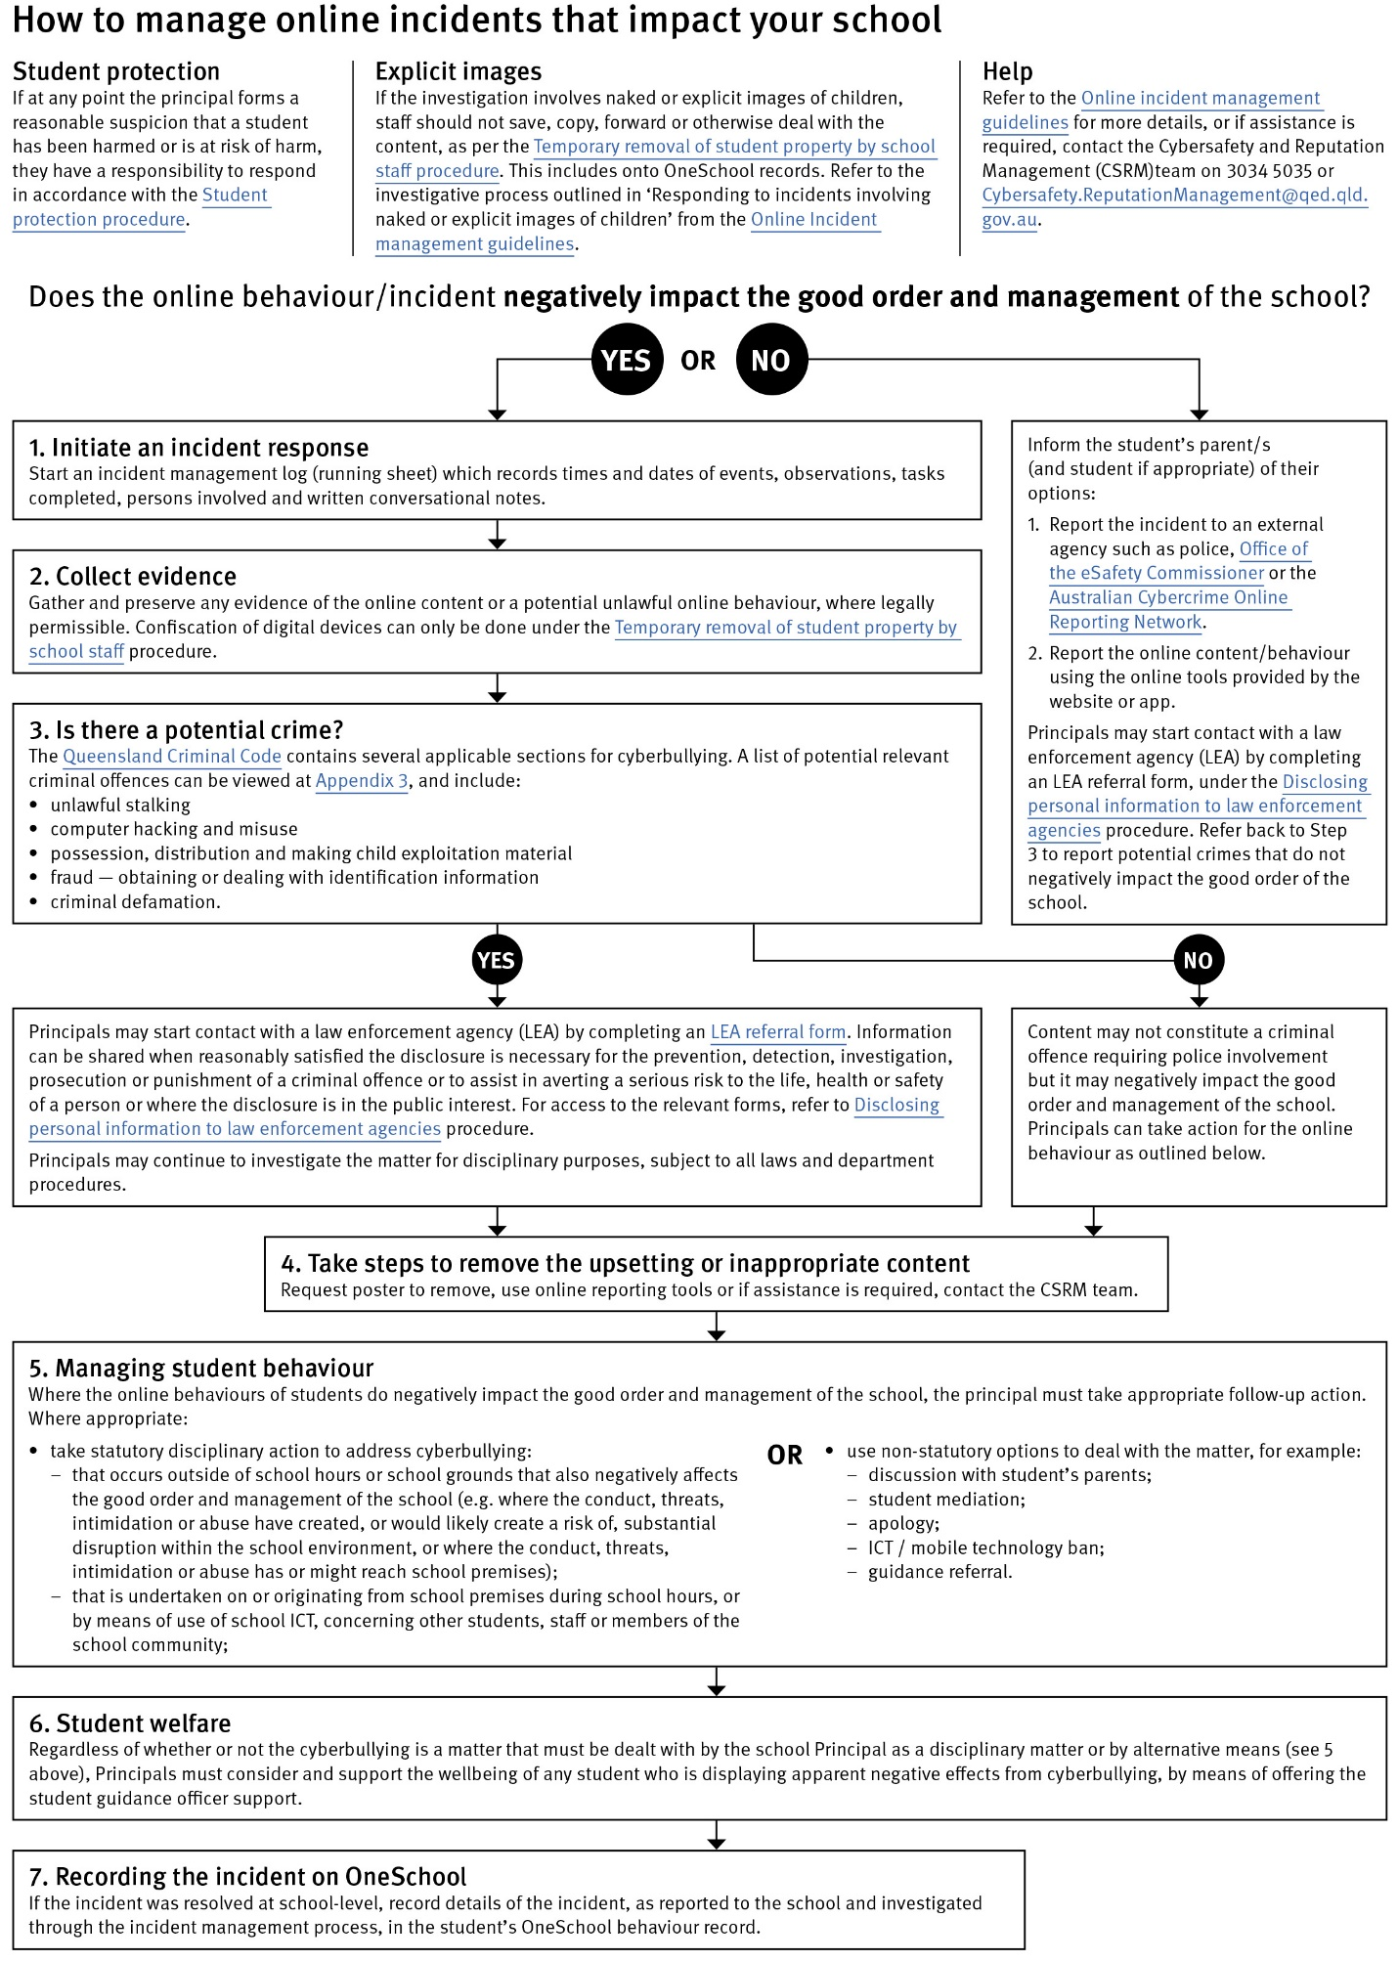

|  |
| --- |
| Restrictive Practices |
|  |

Homebush SS may need to respond to student behaviour that presents a risk of physical harm to the student themselves or others. It is anticipated that most instances of risky behaviour can be de-escalated and resolved quickly. On some rarer occasions, a student’s behaviour may continue to escalate and staff need to engage immediately with positive and proactive strategies aimed at supporting the student to manage their emotional arousal and behaviour.

In some very rare situations, where there is immediate risk of physical harm to the student or other people, and when all other alternative strategies have failed to reduce the risk, it may be necessary for staff to use restrictive practices.

The use of restrictive practices will always be as a last resort, when there is no other available option for reducing immediate risk to the student, staff or other people. Restrictive practices are not used for punishment or as a disciplinary measure.

The department’s **Restrictive practices procedure** is written with consideration for the protection of everyone’s human rights, health, safety and welfare. There are six fundamental principles:

1. Regard to the human rights of those students
2. Safeguards students, staff and others from harm
3. Ensures transparency and accountability
4. Places importance on communication and consultation with parents and carers
5. Maximises the opportunity for positive outcomes, and
6. Aims to reduce or eliminate the use of restrictive practices.

Very rarely restrictive practices will be required and staff will employ, when necessary, pre-arranged strategies and methods (of physical restraint/ mechanical restraint/ clinical holding) which are based upon behaviour risk assessment or clinical health need and are recorded in advance. The use of planned strategies will only be where there is foreseeable immediate risk consistent with the **Restrictive practices procedure**.

Seclusion will not be used as a planned response and will only be used in serious circumstances for managing an unforeseeable situation in an emergency. It will be used for the shortest time possible and in a safe area that presents no additional foreseeable risk to the student. In such emergencies, a staff member will observe the student at all times and seclusion will cease as soon as possible.

Following the use of any restrictive practice, a focused review will help staff to understand how they responded to the risk in any incident that involved the use of a restrictive practice. Staff will consider whether there are other options for managing a similar situation in the future. This strategy works well for reducing the use of restrictive practices.

All incidents of restrictive practices will be recorded and reported in line with departmental procedures.

|  |
| --- |
| Critical Incidents |
|  |

It is important that all school staff have a consistent understanding of how to respond in emergencies involving student behaviour that seriously endangers the student or others. This consistency ensures that appropriate actions are taken to ensure that both students and staff are kept safe.

A critical incident is defined as an occurrence that is sudden, urgent, and usually unexpected, or an occasion requiring immediate action (e.g. in the community, on the road). The aim in these situations is to bring the behaviour of the student under rapid and safe control. It is not a time to try and to punish or discipline the student; it is a crisis management period only.

Staff should follow the documented plan for any student involved in regular critical incidents, which should be saved and available for staff to review in One School.

For unexpected critical incidents, staff should use basic defusing techniques:

1. Avoid escalating the problem behaviour: Avoid shouting, cornering the student, moving into the student’s space, touching or grabbing the student, sudden responses, sarcasm, becoming defensive, communicating anger and frustration through body language.
2. Maintain calmness, respect and detachment: Model the behaviour you want students to adopt, stay calm and controlled, use a serious measured tone, choose your language carefully, avoid humiliating the student, be matter of fact and avoid responding emotionally.
3. Approach the student in a non-threatening manner: Move slowly and deliberately toward the problem situation, speak privately to the student/s where possible, speak calmly and respectfully, minimise body language, keep a reasonable distance, establish eye level position, be brief, stay with the agenda, acknowledge cooperation, withdraw if the situation escalates.
4. Follow through: If the student starts displaying the appropriate behaviour briefly acknowledge their choice and re-direct other students’ attention towards their usual work/activity. If the student continues with the problem behaviour, then remind them of the expected school behaviour and identify consequences of continued unacceptable behaviour.
5. Debrief: At an appropriate time when there is low risk of re-escalation, help the student to identify the sequence of events that led to the unacceptable behaviour, pinpoint decision moments during the sequence of events, evaluate decisions made, and identify acceptable decision options for future situations.

|  |
| --- |
| Resources |
|  |

* [Australian Professional Standards for Teachers](https://www.aitsl.edu.au/teach/standards)
* [Behaviour Foundations professional development package](https://learningplace.eq.edu.au/cx/resources/file/ef1b8f6c-8158-4ca0-966d-18ba4fa2c1f9/1/index.html) (school employees only)
* [Bullying. No Way!](https://bullyingnoway.gov.au/)
* [eheadspace](https://headspace.org.au/eheadspace/)
* [Kids Helpline](https://kidshelpline.com.au/)
* [Office of the eSafety Commissioner](https://www.esafety.gov.au/)
* [Parent and community engagement framework](http://education.qld.gov.au/schools/parent-community-engagement-framework/)
* [Parentline](https://www.parentline.com.au/)
* [Queensland Department of Education School Discipline](http://behaviour.education.qld.gov.au/Pages/default.aspx)
* [Raising Children Network](https://raisingchildren.net.au/)
* [Student Wellbeing Hub](https://studentwellbeinghub.edu.au/?origin-host=www.safeschoolshub.edu.au)

|  |
| --- |
| Conclusion |
|  |

Homebush SS staff are committed to ensuring every student is supported to feel safe, welcome and valued in our school. There may, however, be occasions where parents need to raise a concern or make a complaint about an issue they feel is adversely affecting their child's education.

All Queensland state schools are committed to ensuring that all complaints - whether they relate to a school staff member or a school's operations - are dealt with in a fair and equitable manner. As a parent or carer, you can express dissatisfaction with the service or action of the Department of Education or its staff, including decisions made or actions taken in a school and/or by the local regional office.

As a complainant, it is your responsibility to:

* give us a clear idea of the issue or concern and your desired solution
* provide all the relevant information when making the complaint
* understand that addressing a complaint can take time
* cooperate respectfully and understand that unreasonable, abusive, or disrespectful conduct will not be tolerated
* let us know if something changes, including if help is no longer needed.

**The Department of Education may not proceed with your complaint if your conduct is unreasonable.**

In most instances, staff members are told of complaints made about them and offered the right of reply. A complainant also has the right to have a support person throughout the process.

The following three-step approach assists parents and school staff in reaching an outcome that is in the best interests of the student:

1. **Early resolution**: discuss your complaint with the school

The best place to raise any concerns is at the point where the problem or issue arose. You can make an appointment at the school to discuss your complaint with your child’s teacher or the principal. You are also welcome to lodge your complaint in writing or over the phone. You can also make a complaint through [QGov](https://www.complaints.services.qld.gov.au/).

Complaints may be lodged by telephone, writing or in electronic format. Email addresses can be accessed through the [schools directory](https://schoolsdirectory.eq.edu.au/).

1. **Internal review:** [contact the local Regional Office](https://education.qld.gov.au/contact-us/state-schools-regional-contacts)

If, after taking the early resolution step, you are dissatisfied with the outcome of your complaint or how the complaint was handled, you can ask the local [regional office](https://education.qld.gov.au/contact-us/state-schools-regional-contacts) to conduct a review. You need to submit a [Request for internal review form](http://ppr.det.qld.gov.au/corp/governance/Procedure%20Attachments/Customer%20complaints%20management/Request%20for%20internal%20review%20form.docx) within 28 days of receiving the complaint outcome.

1. **External review**: contact a review authority

if you are dissatisfied after the internal review, you may wish to contact a review authority, such as the Queensland Ombudsman, and request an independent, external review. More information about external review options is available at [www.ombudsman.qld.gov.au](http://www.ombudsman.qld.gov.au).

Some matters need to be handled in a different way to school matters and will be referred to other areas in the department. These include:

* issues about harm, or risk of harm, to a student attending a state school, which must be managed in accordance with the [Student protection procedure](http://ppr.det.qld.gov.au/education/community/Procedure%20Attachments/Student%20Protection/student-protection.pdf).
* complaints about corrupt conduct, public interest disclosures; or certain decisions made under legislation, which will be dealt with as outlined in the [Excluded complaints factsheet](http://ppr.det.qld.gov.au/pif/policies/Documents/Excluded-complaints-factsheet.pdf).